2021

Annual Report
nn
http://yourwebsite.url
Your Organization Name
Willow Roots

www.WillowRoots.org

2
3-4
5
6
7
8
9

Message from Founders
Mission & Programs
Program Impact & Financial Data
Testimonials
Looking Forward/Meet the Board
Donate & Volunteer
Donors

CONTENTS
Message from Lisa & Nelson

Dear Willowers,
Nelson & Lisa Zayas
Co-founders of Willow Roots, Inc.

As we reflect on the year 2021, we are filled with gratitude and joy. Our first monumental achievement would be moving our humble beginnings from our garage to our new home at 7730 South Main Street. This was a very difficult time for us, we felt unsure of our future and our place in the community. However, after we left our garage, we realized that Willow Roots no longer was just our vision but the vision of the community. It became very evident to us that Willow Roots was indeed spreading its roots and becoming a haven for the family members we serve throughout our community.
This year has also showed us that we were not alone, more volunteers than ever came forth to help in any way they could. We believe that no small act of kindness should go unnoticed, and this belief has given community members their opportunity to shine. Our networking ability is what makes Willow Roots truly a team and a force to be reckoned with. It is the ability to reach out and connect people to the immediate items, jobs, people, and services they need. It is having an ear to the ground and a heart that understands that we are all connected. That having a heart filled with gratitude and compassion can bring and change a community into a more cooperative unit that is able to adapt to the daily challenges.
This year we have had an increase in the number of members at our distributions. We continued to meet that need and to increase our variety of items that we feel are necessary to the wellbeing of our community, including seasonings, health, and a cleaning products section. Willow Roots also purchased three cases of women hygiene products which were given out at distribution and then donated to the high school for free access to all.
We are once again so proud to be part of this amazing group and community that we call home. We will always be grateful for your trust and belief in a little dream that once started in a garage. May we continue to earn your trust and meet your expectations in the year 2022.

Best Regards,

Lisa Zayas, Co-founder & President
Nelson Zayas, Co-founder & Treasurer
Mission
Willow Roots, Inc. seeks to improve the well-being and self-sufficiency of neighbors in need, in the Pine Plains community by providing food, clothing, necessities, programs, and other resources. We are committed to treating all with dignity and respect. We encourage broad involvement and participation by residents and organizations in the community we serve.

Vision:
Willow Roots, Inc. continually identifies and assesses the changing needs and resources of the community, modifying our programs accordingly to meet the needs of our community in the best possible way. Our goal is to help our neighbors in need.

Programs
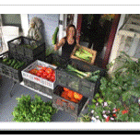
We Care Food Pantry
Willow Roots Food Pantry provides a combination of options that make us unique. In addition to three distributions/month, we also deliver to those who are unable to make it to the pantry. We also announce mid-week distributions using social media which allow recipients to pick up food items from “the front porch” at their leisure. Finally, we are available 24 hours a day/7 days a week for emergencies.
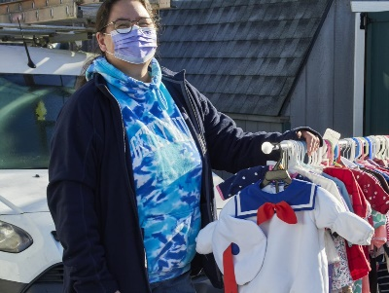
Thrift Shop
The Willow Roots Thrift Shop offers gently used clothes and home furnishings for free. Donations accepted.

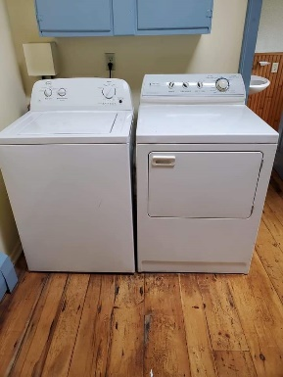
Community Network Services
Willow Roots staff and volunteers work tirelessly to identify community needs, and networks to fulfill those needs. Some of things we were able to accomplish in 2021 include: finding employment; providing bicycles so clients could get to work; connecting people to needed social services, provide appliances such as stoves refrigerators, washers, and dryers; home visits for the elderly, and a place for high school students to fulfill their required community service.
Programs: Continued
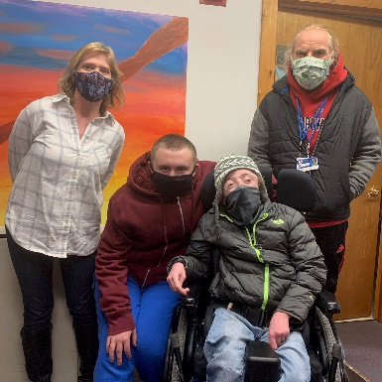
Collaboration with Stissing Mountain HS Special Education Department
Once a week students come to Willow Roots to assist in stocking shelves or preparing bags of pet food for distribution.

Annual Community Holiday Meal
2021 was the 3rd year we have been able to offer a free holiday meal to our clients. This year we were able to feed 150 people. This event is funded by many local businesses and individuals, and the food is prepared by local restaurants.

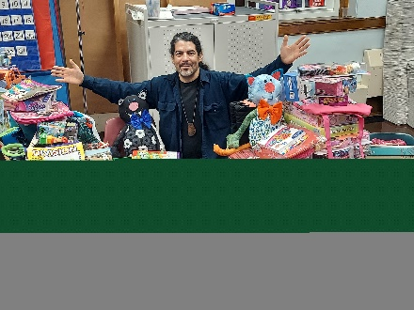
Holiday Helper/Adopt-a-Family Programs
In 2021 Willow Roots was asked to take over the Holiday Helper program at the elementary schools in Pine Plains. This is also our 2nd year assisting the Pine Plains Adopt-a-Family during the holidays. In both programs, local families received free holiday gifts for the children in their family.

Program Impact
In 2021 Willow Roots has distributed food to over 5,000 individuals .
Includes: 716 unique (unduplicated) individuals
comprised of 209 children, 436 adults, and 72 senior citizens
Includes 211 unique (unduplicated) households

- For Thanksgiving we were able to distribute turkeys with dry goods to 71 households.
- For Christmas we were able to distribute turkeys/chickens with dry goods to 72 households.
- We paired up with several local restaurants (efforts led by Dani Nicholson) to distribute Christmas dinners at the Stissing Center parking lot. Even Santa was there!!! 150 people in 57 households were fed
- Willow Roots took over the Holiday Helper program at the elementary schools in Pine Plains. Seven households received huge bags of gifts for their children. Several other applications were collected and forwarded to the Pine Plains Adopt-a-Family program.
This was all possible due to the generosity of donors and volunteers.
Financial Data: Complete 2021 Form 990EZ can be found on our website
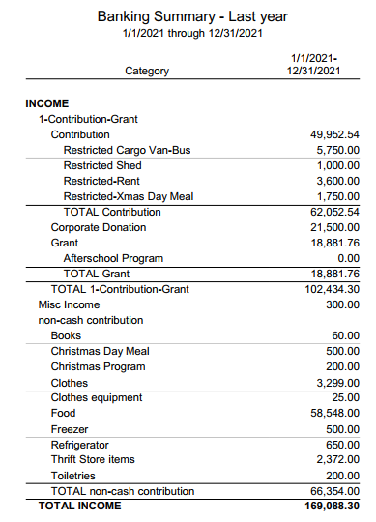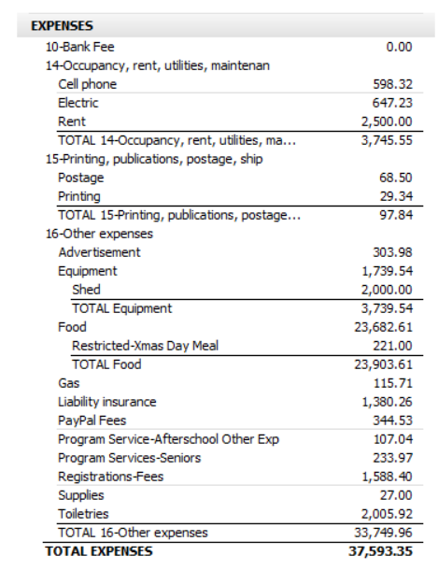
Testimonials
These are just some of the kind responses we have received from the community:
You guys are awe inspiring! Love what you are doing and love that you love doing it. You are both so selfless and humble…Suzy
Lisa, Nelson, thank you for doing all you do for the community… Joyce
You guys are awesome thank you for your loving kindness… Gayle
Lisa Nelson and everyone at willow roots. Thanks for making this an extra special Christmas. Glen and I received the biggest gift and you made it even better kisses hugs and merriment. ..Linda
You guys are one well-oiled machine! I don't know how you do it but you all do it with such ease and grace. So thankful for your presence in the community. God bless …Theresa
couldn't ask for better people in pine plains then Nelson and lisa and all their volunteers. and so on.. they witness some struggles to some families. . without judgment.. bless you …Jason
Did I ever tell you all you are amazing?! God bless you all!...Holly
Thank you for all you do!
Pine Plains is so lucky to have you!...Elizabeth

Looking Forward
As we look forward to 2022, we are filled with such excitement. We are in the process of purchasing a bus that would allow us to carry larger loads. This will eliminate the need for many cars driving to the pick sites and also decrease the frequency of trips. It will also enable us to get more variety.
We are also in the beginning stages of having a free-standing pantry cabinet built by Mr. Gerard Lisella’s math class at Stissing Mountain Jr/Sr High School. This project is the brainchild of the students who picked our group as a charity of choice. After our reading our mission statement of inclusivity they suggested a meeting to discuss a project for food collection. What they decided was more than we could have ever hoped for. A free-standing pantry cabinet would be placed at a location for items to be donated as well as taken. We are so grateful to these students. This idea was something we had dreamed of for the future, but they moved this vision closer to reality in a way we never expected.
As we move into 2022, we will continue to keep our eyes open for more networking opportunities and possibilities. We are continuing to look for ways to improve our community and we are currently working on something that will bring all of us closer together, but for now it is just a dream, or is it?
Meet Our Board of Directors

Lisa Zayas
Co-founder & President
Anibal Garcia
Secretary

Brett McCormack
Vice-President

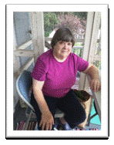
Nelson Zayas
Co-founder & Treasurer

Diana Moore
Board Member &
Board Member

We Need Your Help
Willow Roots is based on a network of people working together to build a stronger community by using the unique strengths and talents of volunteers. In doing so, we all help to transform Pine Plains into a community that enables everyone to feel that they are contributing in whatever way they can. We are Pine Plains Strong!

If you would like to join our team and help accomplish our mission, here are some options:
Volunteer and Help Make a Difference
If you are a high school student who needs community service hours or are just looking to help;
If you like to cook;
If you like to bake;
If you like to grow your own vegetables and would like to donate a portion of your harvest;
If you can spare an hour a week to drive;
If you are interested in joining our glean team (i.e. picking blueberries);
If you are interested in fundraising;
If you are aware of food donation opportunities;
If you are aware of grant opportunities,
Please contact us at:
Call 518-592-1298 or Text 518-751-0164
Or email: WillowRootsInc@gmail.com
For Financial Donations
Checks can be mailed to:
Willow Roots
23 N Main St
Pine Plains, NY 12567

Or PayPal: WillowRootsInc@gmail.com

Thank You to All of Our 2019-2021
Donors & Volunteers
Due to the overwhelming support we have received this past year, we are unable to list everyone here, however, they are listed on our website.
To view the complete list, please visit our website:
www.WillowRoots.org

2021

Annual Report
nn

Connect With Us!
(518)592-1298 | Email: WillowRootsInc@gmail.com
www.WillowRoots.org

nn

